The White Wolf Adventure.

A The Witcher III Wild Hunt™ Mod

*by Nolenthar*

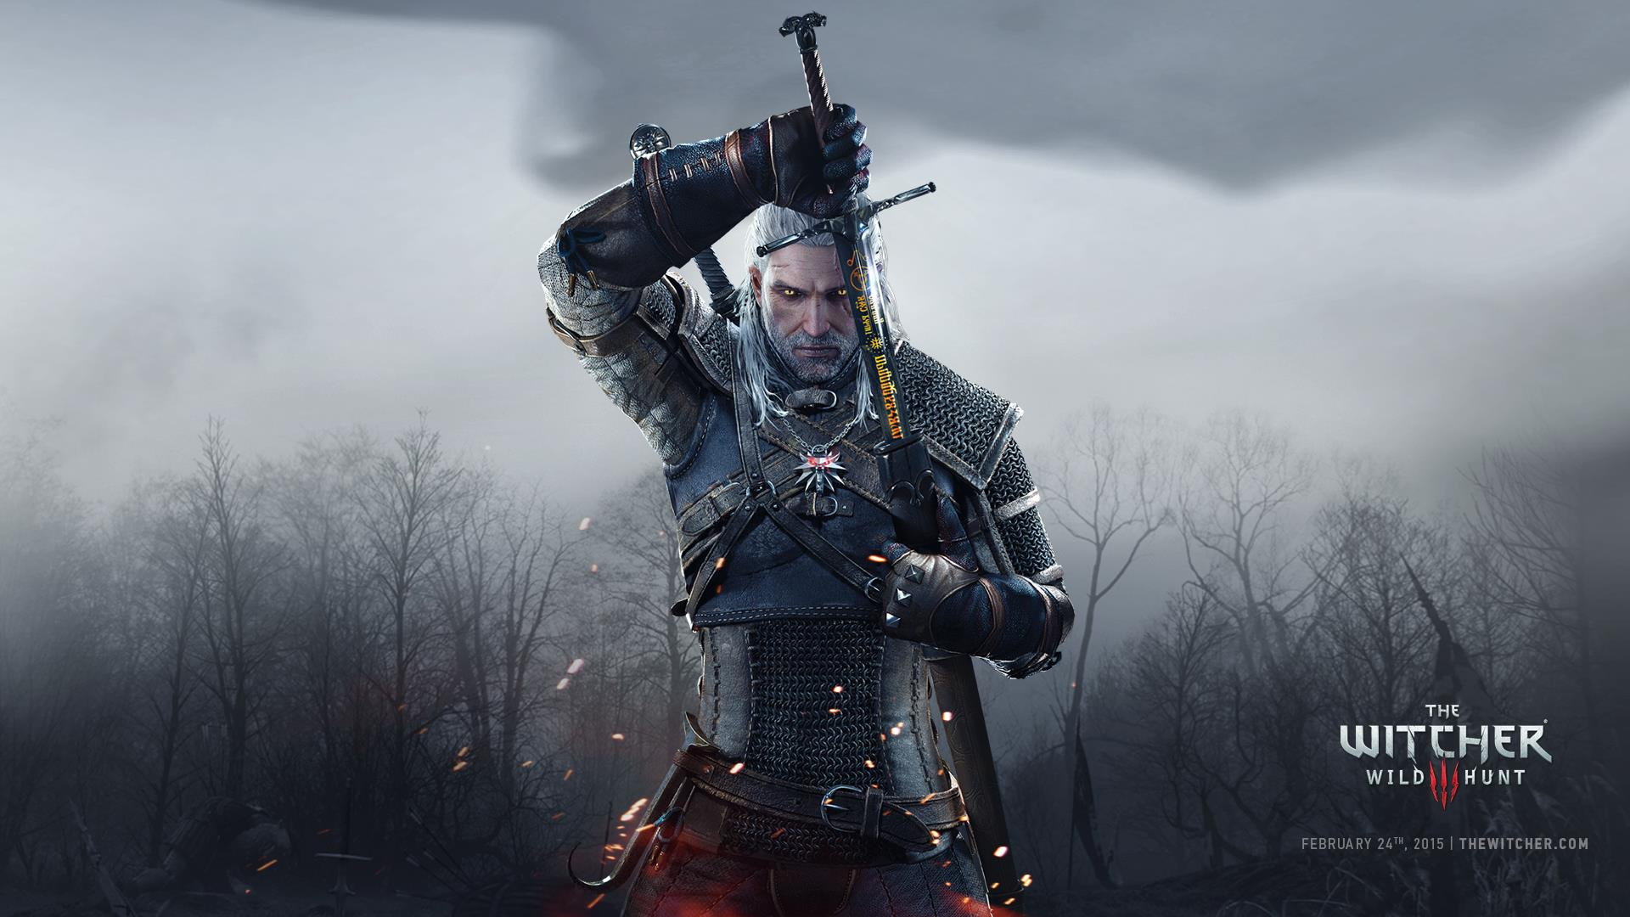

User Guide

Table of Content

I. What is The White Wolf Adventure ? 3

II. Credits 3

1. What is The White Wolf Adventure ?

*The White Wolf Adventure is a very personal vision of what The Witcher 3 should have been when released by CDPRojekt Red. It’s entirely personal, and doesn’t aim to cater to a lot of individuals. It’s released and made public just to give others the opportunity to play The Witcher 3 the same way I do. I absolutely love The Witcher 3, and you will not find in this mod, or those pages, any anger toward the great job accomplished by CDPR. However, they did game design choices I do not necessarily agree with, and this mod is my attempt to correct this.*

*This mod is a full experience; it doesn’t come with modularity nor willingness to cater to different type of Witcher 3 gamers. This mod is unlikely to be compatible with your favourite sword mod, nor with any mods that are not purely aesthetic really. I would definitely not advise to try to mix or merge this to any mod that changes weapons, skills, monsters, potions or alchemy.*

*The White Wolf Adventure is built around the sole idea of making The Witcher 3 wild Hunt even closer to the lore, and you will feel it as you play the game. This is true to the lore, this is made for purist, this is meant for people who knows The Witcher world, who loved The Witcher 1 and enjoyed every minute of The Witcher 2.*

*In this user guide, I will be introducing the new features and the new mechanism of this game. Please note White Wolf Adventure will often be called WWA in the following pages.*

1. Credits

*Even though The White Wolf Adventure is a personal project, it would not be the same without the people listed here whose work has been used, sometimes partially, sometimes completely. Some of them only provided support, but they are all part of the adventure, so to speak. Whether you like WWA or not, I’d strongly advise to visit their nexus page and look out for their mods. Those guys (or girls) are great modders and it’s really worth checking what they do.*

* *Erxv for his Health Bar Mod & his Drinking & Eating animation and for his constant help during modding sessions.*
* *KNG for helping build the community, and being a neverending source of knowledge.*
* *Kukassin for ESGO who taught me many things about scripting with W3.*
* *PMark for the best ever camera mod, integrated in WWA, Absolute Camera.*
* *SkacikPL for the knives mod, the bombs mod and his great help during modding sessions.*
* *WGhost81 for the awesome Preparations Mod & Friendly HUD, whose work has been partially included in this mod.*

1. Integrated Mods

*WWA is a fully built experience. For this reason, it comes pre-built with other mods which are unavoidable, in my opinion. It’s a choice really, and I don’t doubt that some people may disagree with me there. Needless to say, written approval has been given by all respective authors of those mods.*

* Absolute Camera, by PMark : the mods come unmodified. It’s the best camera mod available on the nexus, with every option you can dream of. It’s also fully configurable so you don’t even need to use the mod if you prefer a vanilla camera experience.
* Eat & Drink Animation, by Erxv : those mods
* Friendly HUD, by WGhost 81 : minute some aesthetic modifications, the mods come unmodified. Friendly HUD is also fully configurable, and comes with no cons, only pros, and thus it was obvious to me it needed to be included.
* Eat